ASSIGNMENT – 7.3
2303A51123
Batch-10

Task-1
Prompt: generate a python program to fix the synatx errors that add two numbers with functions with a missing colon and give user input for the numbers.
code :
def add_numbers(num1, num2): return num1 + num2 # Get user input for the numbers number1 = float(input("Enter the first number: ")) number2 = float(input("Enter the second number: "))
# Call the function and display the result result = add_numbers(number1, number2) print("The sum of", number1, "and", number2, "is:", result)

Output :
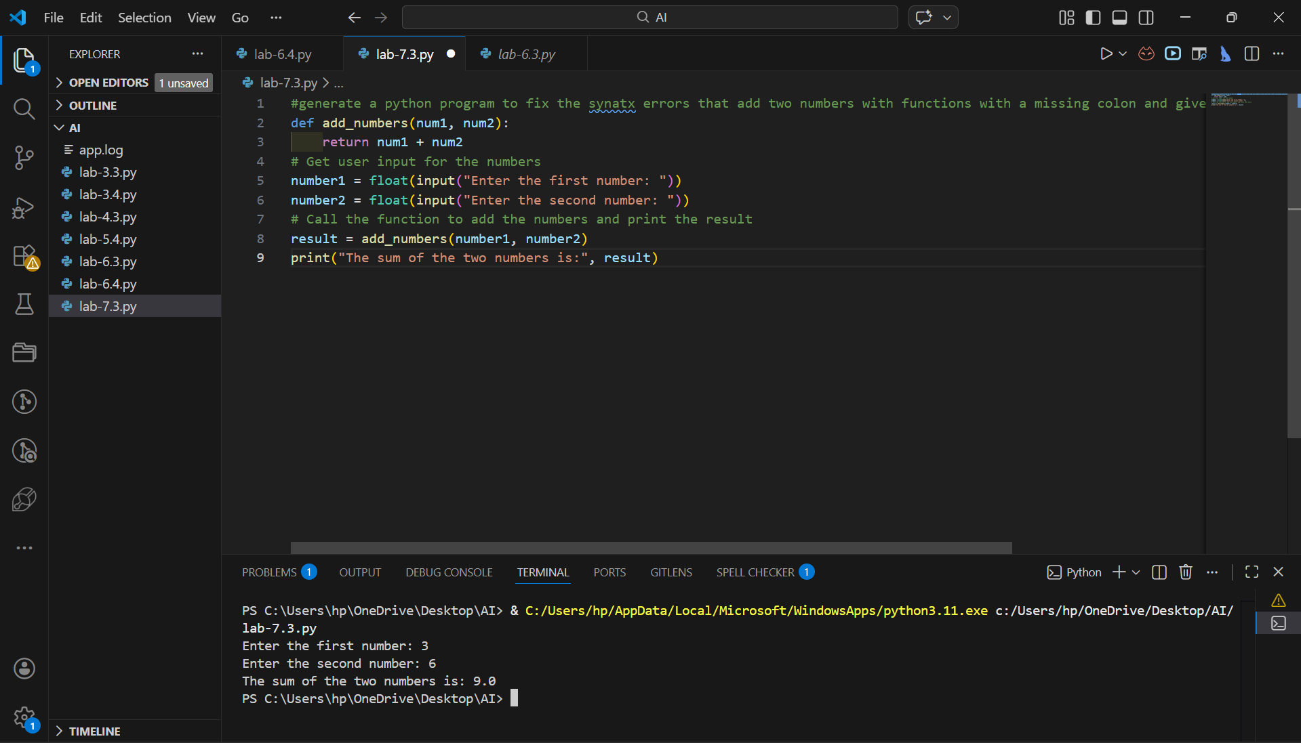
Code Analysis:
- The function add_numbers() takes two parameters and returns their sum.
- The missing colon after the function definition is corrected.
- User inputs are converted to float to allow decimal values.
- The function is called with user inputs and the result is printed.
- Using functions improves reusability and modular programming.

Task-2
Prompt: Debugging logic errors in loops with a simple function program that increment or decrement a counter based on user input.

Code :
def update_counter(counter, action): if action == 'increment': return counter + 1 elif action == 'decrement':
return counter - 1
else:
return counter # Initialize counter counter = 0
# Taking user input for action action = input("Enter action (increment/decrement): ")
# Updating counter based on user input and printing the result counter = update_counter(counter, action) print(f"Counter value after {action}: {counter}")
Output :
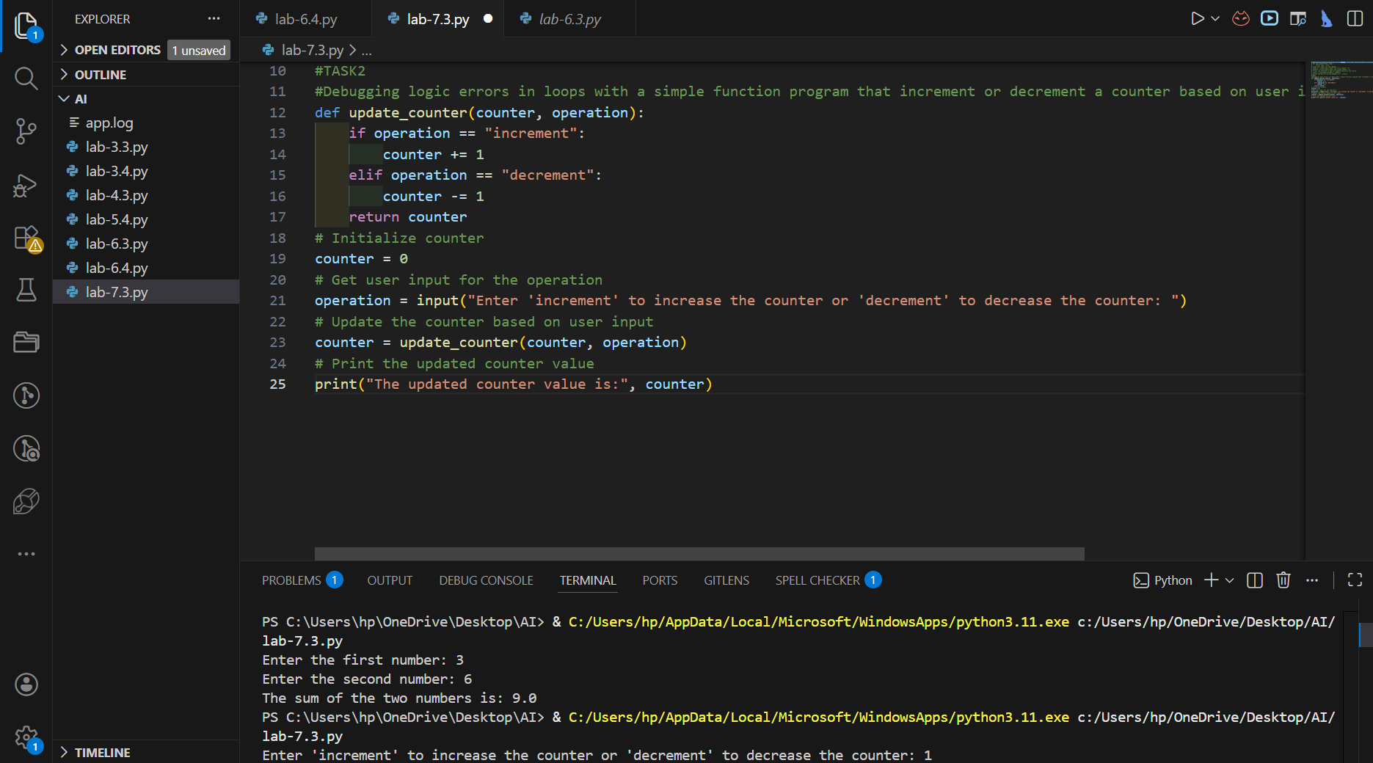
Code Analysis:
- The function modifies the counter based on user action.
- action.lower() avoids case-sensitivity issues.
- If invalid input is entered, the counter remains unchanged.
- The logic ensures proper increment/decrement functionality.
- This demonstrates basic debugging of logical conditions.
Task-3
Prompt: generate a code that to handle runtime errors(division by zero) without validations and use try and except blocks to catch the error. take user input with functions

Code : def divide_numbers(num1, num2):
try:
result = num1 / num2 return result except ZeroDivisionError: return "Error: Division by zero is not allowed."
# Get user input for the numbers
number1 = float(input("Enter the numerator: ")) number2 = float(input("Enter the denominator: ")) # Call the function and display the result result = divide_numbers(number1, number2)
print("The result of dividing", number1, "by", number2, "is:", result) Output:

Code Analysis :
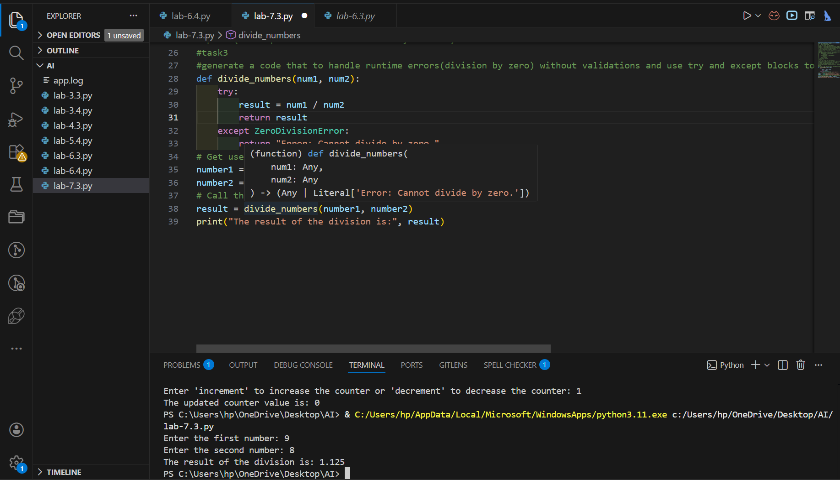
- The function attempts division inside a try block.
- If the denominator is zero, ZeroDivisionError is caught.
- The program does not crash due to exception handling.
- A user-friendly error message is returned instead.
- try-except ensures runtime stability.

Task-4
Prompt: #generate a code to debug the class definition errors for a rectangle .provide a
class definition with missing self-parameter and correct it using __init_ method and explain why self is used in class definitions .take user input

Code :
class Rectangle: def __init__(self, width, height):
self.width = width self.height = height def area(self):
return self.width * self.height # Get user input for width and height width = float(input("Enter the width of the rectangle: ")) height = float(input("Enter the height of the rectangle: ")) # Create an instance of the Rectangle class rectangle = Rectangle(width, height) # Calculate and display the area of the rectangle print("The area of the rectangle is:", rectangle.area())
# Explanation: The self parameter is used in class definitions # to refer to the instance of the class. It allows us to access and modify the attributes of the instance.
# In the __init__ method, we use self to assign the width and height values to the instance variables.
Output:
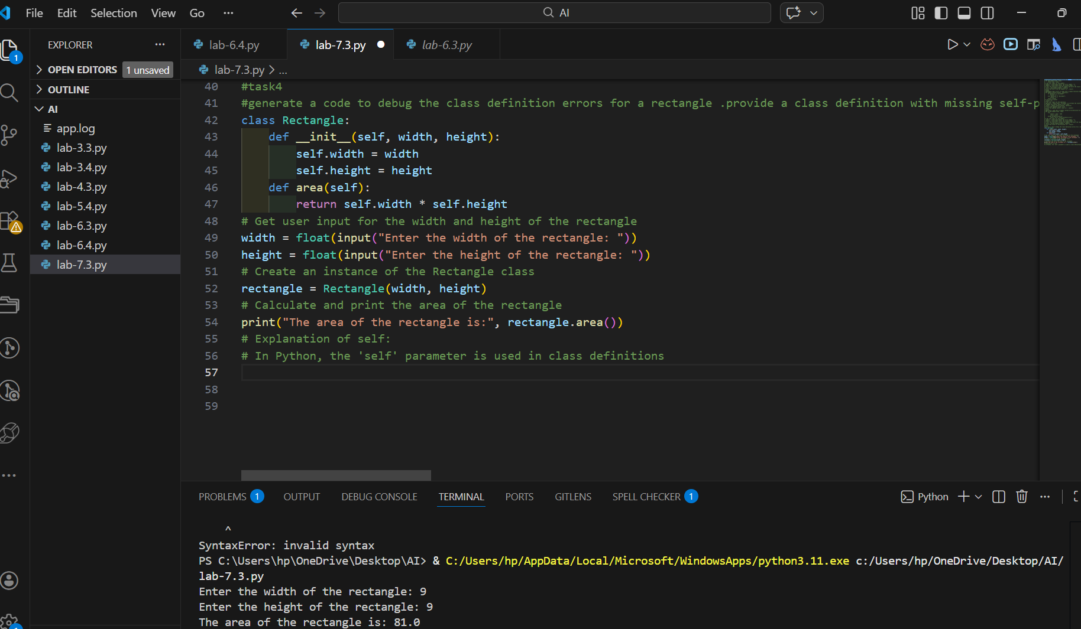
Code Analysis :
- The constructor method must be __init__ (double underscores).
- self refers to the current object instance.
- Instance variables (self.width, self.height) store object data.
- The area() method accesses instance variables using self.
- Without self, Python cannot link data to the specific object.

Task-5
Prompt: generate a code to resolve the index errors in list.give the code that to accesses an out of-range list index and correct it by using exception handling and explain the importance of handling index errors in list operations. take user input for list elements.
my_list = [1, 2, 3] try:
# Attempting to access an out-of-range index print(my_list[5]) except IndexError:
print("Error: Index out of range. Please provide a valid index.")
# Get user input for list elements user_input = input("Enter a list of numbers separated by commas: ")
# Convert the user input into a list of integers my_list = [int(x.strip()) for x in user_input.split(",")] # Attempt to access an index based on user input
try:
index = int(input("Enter the index you want to access: ")) print("Element at index", index, "is:", my_list[index]) except IndexError:
print("Error: Index out of range. Please provide a valid index.")
# Explanation: Handling index errors in list operations is important because it prevents the program from crashing when an invalid index is accessed. By using exception handling, we can catch the error and provide a user-friendly message, allowing the program to continue running smoothly even when unexpected input is encountered.

Output :
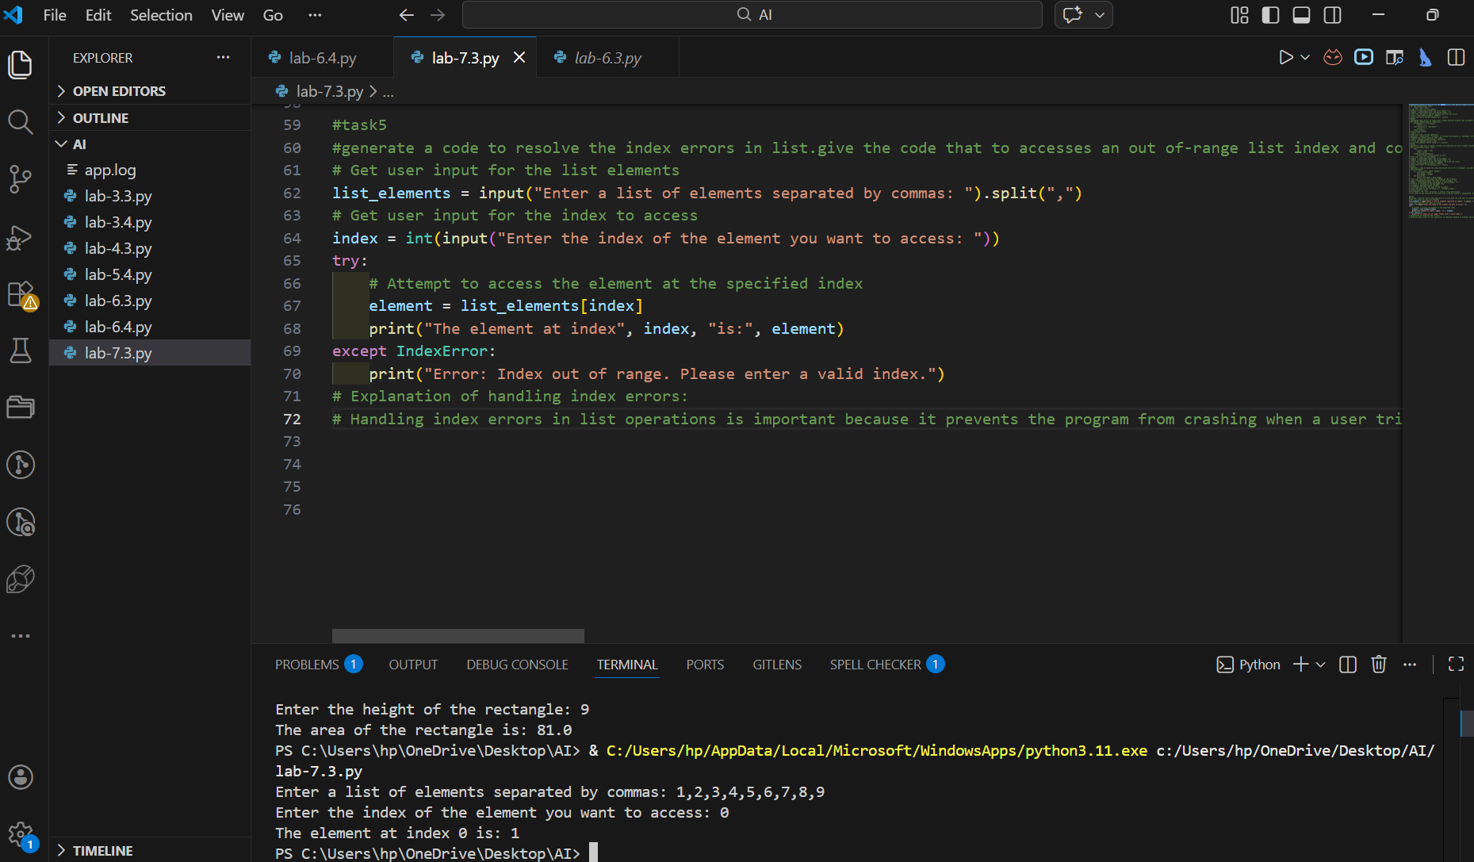

Code Analysis :
- User input is converted into a list using split() and list comprehension.
- The program attempts to access a user-specified index.
- If index is invalid, IndexError is handled gracefully.
- ValueError ensures proper numeric input.
- Exception handling prevents program crashes and improves reliability

